Internet Brings More Harm Than Good

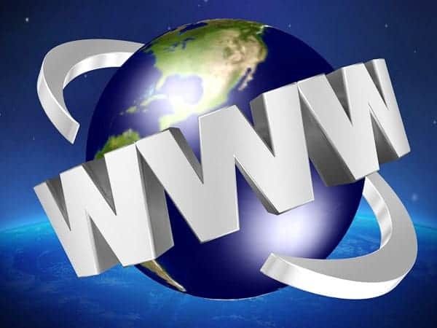

Table of Contents

[](https://debatewise.org/3033-internet-brings-more-harm-than-good/)

Has the arrival of the internet done more harm than good?

All the Yes points:

1. [The internet has become a major source of information for many people. However, online information …](https://debatewise.org/3033-internet-brings-more-harm-than-good/#yes1)
2. [Everyone’s privacy is greatly harmed by the internet. We can quickly see what politicians and celeb…](https://debatewise.org/3033-internet-brings-more-harm-than-good/#yes2)
3. [You can choose any identity you want when you are online. Many people hide behind profiles they hav…](https://debatewise.org/3033-internet-brings-more-harm-than-good/#yes3)
4. [Many people are just addicted to the internet. They can’t stop browsing, they are hooked on gaming …](https://debatewise.org/3033-internet-brings-more-harm-than-good/#yes4)
5. [Since the nineties, instant messaging and emailing has been used to extract passwords, bank account …](https://debatewise.org/3033-internet-brings-more-harm-than-good/#yes5)
6. [The internet has allowed big companies to capture a lot of business online while smaller, local comp…](https://debatewise.org/3033-internet-brings-more-harm-than-good/#yes6)

All the No points:

*The internet has become a major source of information for many people. However, online information …*

Yes because…

The internet has become a major source of information for many people. However, online information has usually not gone through the same checks as newspaper articles or books. There is a higher risk that some of the facts or quotations from a particular source in an article are false. Whereas newspapers might lose customers if people find out they gave been ‘selling lies’, a blog can be easily deleted. If people base their opinions on information they find online, they could well be basing their opinion on false facts. Since the internet gives equal space to material of greatly varying quality, this is a serious risk.

No because…

The internet gives millions of people access to information they would not otherwise have had, which is a huge benefit. And people who read the news online are not that easy to fool. Especially when you spend a lot of time online, you can tell bloggers who just want to shout from bloggers who carefully refer to their sources. The type of people this argument worries about are not the type of people that read high quality newspapers in the first place, they would read the trashy ones. The problem of bad information and news making is not unique to the internet; there are lots of trashy magazines as well. We learn in schools to double-check our sources and not believe everything we read, and we can apply that skill whilst surfing the internet.

*Everyone’s privacy is greatly harmed by the internet. We can quickly see what politicians and celeb…*

Yes because…

Everyone’s privacy is greatly harmed by the internet. We can quickly see what politicians and celebrities are doing when the paparazzi posts news pictures online, but people can also see what we’ve been doing. Some sites store information. Some ask us to fill in information which can be sold to other sites for commercial purposes. Once we post something online, it is almost impossible to erase it from the net. For example, if I break up with a person, they can take revenge and post embarrassing photos of me online. There have been numerous court cases where a woman demanded that her ex remove some privately taken photos from a dating site, so that she would be left alone. Unfortunately, the law cannot protect your right to privacy in this area.

No because…

You are the first and most important person to protect your own privacy. Don’t fill in private information, if you don’t want people to know about it. There are laws protecting you from websites that just sell on your information, but if you give personal information out without being sure that it will be properly used you only have yourself to blame.

*You can choose any identity you want when you are online. Many people hide behind profiles they hav…*

Yes because…

You can choose any identity you want when you are online. Many people hide behind profiles they have made up. They start making nasty remarks on public forums or chat rooms. They would never have normally said these things, but because they can hide behind an identity they start upsetting and hurting others. Even though other people can try to stop them from this behaviour, their warnings are not as effective as a warning from someone you know very well, like a friend, a parent or a teacher. The internet’s anonymity allows them to show sides of themselves that, for good reasons, they normally wouldn’t have shown. This increases the risk that, because they get away with it online, they show similar behaviour in their real life. This harms everyone.

No because…

Against this group of people who misbehave online is a group of people who have finally found individuals with similar mindsets. Not everyone likes the same things and the more unusual your preferences, the harder it will be to find friends. The internet has finally given many people a place where they can be themselves, and where they can meet likeminded people. It is a great relief for them that they do not have to fear being discovered by people they know.  
  
You cannot let a small group of badly behaved people ruin the freedom of many others. We should work on creating better policies to deal with rude people, but we should not go back to the old situation where people who are different in some way end up feeling isolated and lonely.

*Many people are just addicted to the internet. They can’t stop browsing, they are hooked on gaming …*

Yes because…

Many people are just addicted to the internet. They can’t stop browsing, they are hooked on gaming and they spend too much time indoors. Instead of going out for a walk or play outside, they sit behind their computers for hours. A sad consequence of the addiction is that they are so used to high speed information by just clicking on the next link that they can no longer appreciate a good book, or a nice conversation with a friend. By failing to take exercise they grow fat and unhealthy. Their family life suffers and their only relationships are online – they can’t cope in the real world.

No because…

There is nothing wrong with sitting indoors. It’s better to sit indoors and actively research and surf online than to sit in front of a television and passively take in what the TV company decided you should watch. 20 years ago people used to worry kids spent too much time inside watching TV, but viewing hours have dropped as people choose to use the internet instead. There are lots of educational games and news sites we can browse around and learn from in much more effective way than television could ever provide. Furthermore, many people keep up their social contacts online. Saying they cannot appreciate a nice conversation, or a good book is just a wild claim.

*Since the nineties, instant messaging and emailing has been used to extract passwords, bank account …*

Yes because…

Since the nineties, instant messaging and emailing has been used to extract passwords, bank account details or credit card numbers. This phenomenon is called phishing. A phisher uses professional-looking websites and profiles, and tens of thousands of people have lost hundreds of thousands of dollars to phishers. If we could better control who contacts us, this would not have happened on such a large scale.

No because…

It is unfortunate that people who are willing to help have been abused by others. However, there have been many campaigns that raise awareness about phishing. Governments and banks have provided guidelines about how to recognize phishers. We should firmly deal with the crime of phishing, but not forget how much easier our life has become now that we can do our financial business online and via bank cards.

*The internet has allowed big companies to capture a lot of business online while smaller, local comp…*

Yes because…

The internet has allowed big companies to capture a lot of business online while smaller, local companies have lost out. And because the internet makes it easier to get work done abroad, jobs have left many western countries for low-wage countries abroad.

No because…

The internet has brought greater prosperity, allowing lots of different businesses to set up online. This has brought a lot more choice to ordinary people, and also driven down prices as people find it easier to compare different companies products. Small businesses can cheaply set up online and find a market for their goods and services. And by making it easier to work anywhere with an internet connection, it has allowed many more people to work from home and to share out projects with co-workers over the whole world.