Fast Food Advertising Should Be Banned

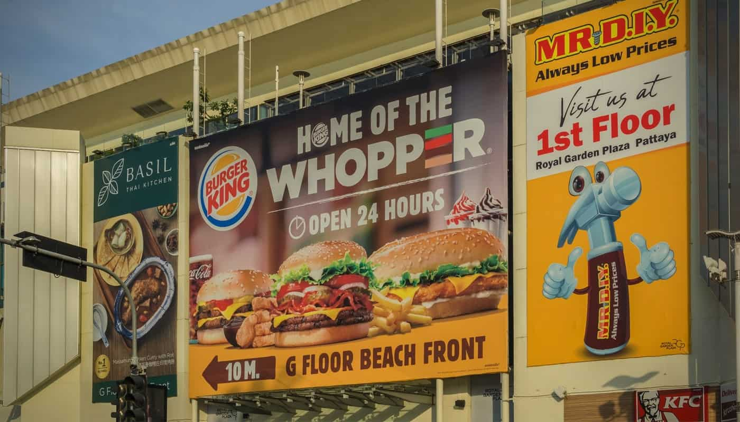

Table of Contents

[](https://debatewise.org/3569-we-should-ban-fast-food-advertising/)

Banning and partial banning of fast food advertising has been a cause for debate globally over the last few years. The call to ban has been in large part due to the influence these businesses have on childhood obesity rates. Another factor driving the debate is health issues in the general population from the consumption of fast foods. Diabetes, intestinal problems, and poor dental health are all contributed to by processed foods and high sugar content drinks that are the mainstay of fast food restaurants.

All the Yes points:

1. [Fast Food Advertising and Childhood Obesity](https://debatewise.org/3569-we-should-ban-fast-food-advertising/#yes1)
2. [Fast Food, Diabetes and Heart Disease](https://debatewise.org/3569-we-should-ban-fast-food-advertising/#yes2)
3. [Long term damage](https://debatewise.org/3569-we-should-ban-fast-food-advertising/#yes3)
4. [Fast Foods and Functional Gastrointestinal Disorders](https://debatewise.org/3569-we-should-ban-fast-food-advertising/#yes4)
5. [Fast Food and Your Dental Health](https://debatewise.org/3569-we-should-ban-fast-food-advertising/#yes5)

All the No points:

1. [Its a business, a business doing its job](https://debatewise.org/3569-we-should-ban-fast-food-advertising/#no1)

*Fast Food Advertising and Childhood Obesity*

Yes because…

Since the 1970s fast food advertising and ads targeting children specifically have increased dramatically. At the same time, the instance of obesity has also skyrocketed. It is difficult to deny the link between increased fast food advertising and childhood obesity. According to the [Kaiser Family Foundation](http://www.kff.org/other/issue-brief/the-role-of-media-in-childhood-obesity/), approximately 50 percent of ads children are exposed to are food related. Of these none are for fruits, vegetables, or other healthy choices. Children are exposed to nearly 21 advertisements per day, and of these only one every two to three days is a public service announcement for healthier eating. Studies by the [American Psychological Association](https://www.apa.org/pubs/info/reports/advertising-children) show advertisers spend more than twelve billion dollars per year on ads targeting children. If these were not particularly effective, this would be a very poor investment from the food industry. To investigate this trend, the Task Force on Advertising and Children was formed. Their research shows children’s product preference begins with a single commercial viewing. Additional viewing serves to further strengthen the child’s preference for a particular product. The [American Psychological Association](http://www.apa.org/pubs/info/reports/advertising-children.aspx) further notes a great deal of research shows eating unhealthy fast foods and excluding healthy alternatives leads to obesity and overall poor health. The trend has been reported on repeatedly. [Dr. Victor Strasburger](http://www.reuters.com/article/us-fastfood-ads-idUSTRE75Q0K820110627) recently told Reuters news agency, “Just by banning ads for fast food, one study says we could decrease obesity and overweight by 17 percent.” That reduction in childhood obesity alone should be enough to ban fast food advertising.

No because…

Fast food doesn’t necessarily make people fat, just unhealthy (cholesterol, starch etc) . See, I’m not fat but I don’t feel healthy because I barely have any muscle and I live on fat, sugar and starch mostly. I need to change my diet and exercise.  
  
Fast food chains are also offering balanced diets, high protein, salad bowls etc are all on the menu even at pizza hut and McDonald’s. It is also the obligation of the parents to police what their children view and how much screen time they get. If parents today took a more proactive approach, spending more personal time and using television less as a babysitter we would see less obesity in children. Also parents today need to remember they are the ones in charge, not the children. There seems to be a trend today where parents are afraid to anger the child by saying no. Perhaps some of the blame for the increase in childhood obesity rates lies with the hands off approach to parenting which has become the norm in modern society.

*Fast Food, Diabetes and Heart Disease*

Yes because…

Setting aside the risks to children, there are a number of health concerns for anyone consuming fast food. In a research paper published by the [University of Minnesota](http://circ.ahajournals.org/content/126/2/182) eating fast food just two or more times per week increases the risks of developing type 2 diabetes by an astounding 27 percent. The same study also determined eating fast food one time per week increased the risk of death by coronary heart disease by 20 percent. Having two to three fast food meals a week ups the risk to 50 percent. If you enjoy dining four or more times each week on fast food, your risk of death from coronary heart disease climbs to a terrifying 80 percent. Researchers from the university had noted nearly all studies into the health risks associated with the consumption of fast food had been conducted here in the United States and other developed western countries. The myriad of other risk factors available in western culture that increase the likelihood of these diseases has often been utilized to discredit the results of similar studies. To avoid the possibility of clouding the results, the University of Minnesota study was conducted in Singapore. At the time of the study western style fast food was a new introduction to a primarily eastern culture. With the increased consumption of fast food by the local population came dramatically increased rates of heart disease and diabetes. It is important to note the majority of the study participants with the highest intake of fast foods were from the younger generation and led more active lifestyles. The people showing the greatest effect from the introduction of fast food to their diets would typically be those with the lowest risk factors for these diseases. Numbers are incapable of lying. Findings from the University of Minnesota research study clearly show the correlation between fast food consumption and the increased risks of both coronary heart disease and diabetes. Tobacco and alcohol were banned from television advertising because of the health risks to the general public. With fast food consumption posing such a serious risk to public health, their advertising should also be banned.

No because…

There is little to be said against this particular argument for the banning of fast food advertising. The only conceivable rebuttal that could be brought to bear is that of personal choice and responsibility. The sole purpose of advertising is to convince the individual they have a preference or desire for one product over other available options. It becomes a matter of personal responsibility to either abstain from consuming unhealthy foods or use in moderation. All the health risks listed can be mitigated through self control with regards to frequency and portion sizing combined with a healthy lifestyle including exercise.

*Long term damage*

Yes because…

It does long term damage to individuals leading to countless diseases eventually and its promotion should be banned as is cigarrete ads.

No because…

Do folk not have a choice ?. No one makes them eat or smoke. People have always had the choice, and some decide to eat what they like and when, and then walk away instead of getting a taxi or daddy to collect. It is the fat people who have given these eating establishments a bad name.

*Fast Foods and Functional Gastrointestinal Disorders*

Yes because…

Another set of health problems associated with eating fast food are called Functional gastrointestinal disorders which include Irritable bowel syndrome, chronic idiopathic constipation and abdominal migraine. A study published in 2016 by the [University of Washington](http://apjcn.nhri.org.tw/server/APJCN/25/2/393.pdf) in association with the National Yang Ming University in Taiwan investigated the possibility of fast food causing these disorders. The research found slightly more than 88 percent of adolescents suffering with functional gastrointestinal disorders were frequent consumers of fast food. Their findings concluded a significant correlation between fast food consumption and functional gastrointestinal disorders. This study determined the likely cause of gastrointestinal disorder to be high concentrations of sodium, fat and sugars. Also excessive concentrations of trans fatty acids found in fast food contribute to disorders of the gastrointestinal tract. This consumption of fats and sugars coupled with a lack of fruits, vegetables, and sources of dietary fiber lead to imbalance in the natural flora required in the intestines for proper digestion. Abdominal migraine was the most common affliction associated with fast food induced functional gastrointestinal disorder. According to [Migraine.com](https://migraine.com/migraine-types/abdominal-migraine/) children who deal with abdominal migraines in their youth frequently suffer from migraine headaches later in life. These children are also more likely to develop psychiatric problems such as anxiety in adulthood. These life altering long term effects are further cause to eliminate fast food advertising.

No because…

*Fast Food and Your Dental Health*

Yes because…

There are a few ways in which a fast food diet is harmful to your oral health. [Russell Roderick](http://www.dentistrytoday.com/news/todays-dental-news/item/1669-how-fast-food-impacts-your-patients-oral-health), who holds a doctorate of medicine in dentistry degree, states the primary concern for dental health with fast food is the high content of salt and sugar. When these foods are consumed the added salts and sugars tend to help food particles stick to tooth surfaces. Food stuck to the teeth allows acids to build up on the surface. It is the buildup of these acids that causes tooth decay and cavities. A secondary contributing factor to dental problems related to fast food is the soft drink. Typically soda is consumed with fast food meals. Workers in fast food restaurants are trained to ask if you want a soda with your meal. Many years of dental research have shown the sugars and carbonation in these beverages wear down the enamel of teeth. Enamel is your tooth’s protective coating, without it you are exceedingly prone to cavities and tooth decay. Finally, as mentioned earlier a diet of fast food significantly increases the risk of contracting type 2 diabetes. Diabetes comes with its own dangers to good oral health. People that are diabetic show a significant increase in the risk of periodontal disease. Diabetics must maintain proper blood glucose levels to help prevent oral health problems. Registered nurse [David Spero](https://www.diabetesselfmanagement.com/blog/foods-strange-tricks/) explains in his article for diabetes self management that increased fat content in fast food creates complications in controlling the levels of sugar in the blood by delaying the release of glucose into the system.

No because…

Business has a right to advertise its product. Without successful advertising the industry would undoubtedly shrink. The resulting loss of employment for fast food workers would bring its own set of dangers to health and well being.

*Its a business, a business doing its job*

No because…

So what if they advertise? Its your self control that says “no i shouldn’t have that today”. If you don’t like it, then don’t like it. But lets face, they have hundreds of customers per day. Just because you dont agree with fast food doesn’t mean no one does. Should we ban advertisements for cookies? Soda? Energy drinks? other ‘junk food’? Besides, eating a big mac, some fries and a drink from mcdonalds is better than eating most dishes you can get at an italian restaurant. In face, pizza is really bad for you too. Should we ban pizza advertisements? Do some research to whats bad for you. Most things contain something that people complain about. From Vitamin Water to Perscription Medications. And yes, Meds that have advertisments could be bad for you too! In turn, with the logic of the “yes” argument, nothing should be advertised.