**DEBATE MOTIONS** ΟΜΙΛΟΙ ΓΕΛ ΚΑΣΤΡΙΤΣΙΟΥ

* This House believes nuclear energy is a way to go
* This House would apologise to Native Americans
* This House would ban make up  in middle schools
* This House believes video games make more harm than good
* This House believes there is too much violence in media
* This House believes violence in media causes violence in society
* This House would eliminate age restrictions for marriage

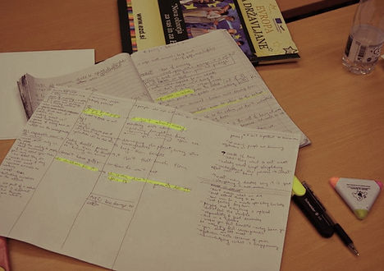

* This House believes there is too much sex in the media
* This House would abolish ZOOs
* This House advocates human colonisation of outer space
* This House believes that politicians should not be allowed to publish their autobiographies during their lifetimes
* This House would go to the elections
* This house supports military intervention to deliver emergency aid in humanitarian crises
* This house believes that governments have a duty to bail out failing financial institutions
* This house would ban the use of unethically obtained data in scientific research
* This house would make the directors of multinational companies personally liable for environmental abuses committed by their companies in the developing world
* This house would expand the permanent membership of the UN Security Council
* This House would ban the broadcast of recordings produced by terrorists
* This House would require all schools to teach safe sex to children from age 10 regardless of parental consent
* This House would pay morbidly obese people to lose weight
* This House believes developed countries should not accept skilled migrants from developing countries
* This House would make fines relative to wealth
* This House would use military force where necessary to deliver emergency aid
* This House would require people to work in return for welfare payments
* This House believes the European Union should declare that energy security is a legitimate reason for military action
* This house would ban the physical punishment of children by parents
* The mixed sex schools are better than unisex schools
* English should become a  common global language
* Bollywood is better than Hollywood
* Our children’s lives will be better than ours
* We should stop eat meat
* War is never justified
* McDonalds should be banned
* Advertising degrades the quality of life
* We should let convicted criminals to raise their children in prisons
* We should ban advertising which targets  children
* Governments should put a limit on individual energy use
* Obama should be tried at International Criminal Court
* EU experiment failed
* Development aid should be conditioned with recognition of gay rights
* We should tax unhealthy food
* We should ban plastic bags
* THBT online activism is counterproductive
* Hacking is a legitimate way of protest against multinational corporations
* Free Internet is a myth
* In the era of Internet privacy lost its  importance
* We should abandon the authorship rights for music and films
* THBT the internet should be regulated just like all other media
* THBT the internet is a public good
* THBT that an unregulated internet does more harm than good
* In the era of Internet we should introduce a global hate law speech
* Capital controls Internet
* We support censorship on pornography at Internet
* We support Anonymous actions agains governments and corporations
* Citizens should be involved in all the decisions connected with Internet
* THW implement the electronic vote
* We should vote for pirat political parties
* Democracy failed us
* We should abandon democracy
* We support direct democracy
* THBT the European public education system is out of touch with the job market
* THW sanction EU members states that do not ensure protection of sexual minorities
* THBT we should tax products according to their environmental and social footprint
* THBT can not be no equal opportunities without  strong welfare state
* THBT sports should not receive any public funding
* THW make EU universities free
* THB there cannot be equal opportunities without a strong welfare state
* Voting should be obligatory
* We should lower the voting age to 16
* Representative democracy has failed us
* E-elections would increase the participation of youth
* The democratic potential of the Internet is overvalued
* A conscious consumer does for democracy more than a voter
* Invalidate any election result with a turnout below 70%
* Children should be excluded from any religion until adulthood
* We support parents who secretly install spyware on their children’s electronic devices
* Install condom vending machines in all high schools
* We should not force children to sing the national anthem in schools
* Require large online social networks to be controlled democratically by their users
* Allow minors who pass a test on civics to vote
* Parents should have access to their children's social networking sites
* This house would prohibit the media from using software to cosmetically improve an individual’s appearance
* This house believes that hacking is an acceptable form of protest against large corporations
* This house would legally require priests to report all serious crimes that they hear of in confessions
* This house would require persons who work in the media to wait four years before running for public office or working for the government
* This house believes that elective cosmetic surgery should be banned
* This house believes that doctors should never lie to their patients, including one for their own good
* This house would authorise nudism on beaches and in public pools
* Romantic relationships between university instructors and their students should be illegal
* The state should prohibit all items of clothing that cover the face
* Allow companies to refuse hiring smokers
* Criminalise the payment of ransom
* European governments should pay parents to have children

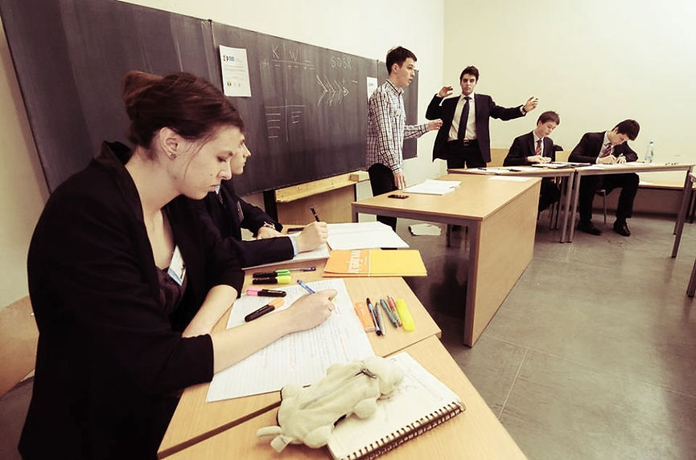

* We should ban boxing
* Women should get an equal position in war with men
* All citizens ought to perform a period of national service
* Have harsher sentences for celebrity criminals
* Marriage is an outdated concept
* Prostitution should be legalized
* Students  in public school should wear school uniforms
* Public money should not be used to finance art
* Strong dictatorship is better than weak democracy
* We should be willing to negotiate with terrorists
* All politicians should be limited to two terms in office
* Nationalism is a virtue
* Convicted rapists should be chemically castrated
* Testing products for humans on animals is immoral
* After cohabiting for six months, couples should be considered as married
* Parents should lose custody of morbidly obese children.
* Child abusers should not be allowed to have more children
* Every citizen should be provided with internet access
* THBT Europe 2020 has failed youth
* THBT The European Parliament needs a trans-European pirate party
* THBT Poverty is the biggest threat to social peace and security
* THBT high youth unemployment makes EU longterm prosperity impossible
* This house supports Anonymous
* THBT Anonymous are terrorists
* THBT The fear of economic crisis has more negative effects than the crisis itself
* THBT Assimilation is a better model than integration for creating cohesive EU societies
* THBT Countries of the EU should have a common history book
* THBT There can be no EU economic union without a political one
* THBT We should introduce a tax on transactions in the EU
* THW favour employers that hire young people over those that hire older workers
* THBT today's young generation of Europeans has less opportunities than they're parents did
* THBT the EU should strongly encourage young families to have more than one child
* THBT social media has made traditional media obsolete
* THBT the EU is in a crisis of democracy
* THBT the youth of Europe is not properly represented in decision making
* THBT Facebook should be controlled democratically by it's users
* THW implement the electronic vote for European Parliament elections
* EU member states should provide primary education for Roma children in their native language
* All European countries should enforce affirmative action for the employment of the Roma
* Roma should be recognised as the first transnational minority in the European union
* We should ban all religious holidays as national holidays
* The EU should grant amnesty to all illegal aliens currently living within its borders
* EU countries should pursue a stronger assimilation policy
* Governments should pay for minorities to be educated in their native language
* EU should sanction its members for denying practice of religious freedom in public
* Governments  should impose common minimal housing and living conditions for low-skilled workers from other countries
* All citizens should be entitled to a basic income without the requirement to work
* All workers should be legally entitled to profit sharing
* Welfare payments should be done through voucher
* University graduates should pay the cost of their university education through a graduate tax

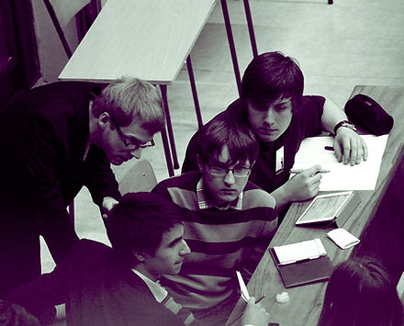

* Unions have lost their power in the European Union
* Competitiveness breads equality
* THBT improving urban living conditions should be the priority of the 21st century
* THBT Europe should not support the French ban on headscarves
* THW ban government funding of religious schools
* THW have a European passport
* THW require migrants wishing to have European citizenship to pass language and value tests
* THW follow the Swedish model for integration
* This house supports  quotas for women at the elections for parliaments
* This house would  not allow public sector employees wear religious clothing or symbols in the workplace
* This house believes that affirmative action to remedy the effects of discrimination is justified
* THW allow people to choose religious courts to rule on family matters
* THW allow polygamy/polyandry in Europe
* We should apologize to the colonies
* This House would include Iran in negotiations for peace in Siria
* THBT Egypt will be better off with a secular authoritarianism than a democratic government
* TH condemn the EU Troika’s reliance on mainly austerity measures as a solution for at risk Eurozone economies
* THBT governments should actively discourage consumerist lifestyles
* THBT all corporations should become workers' co-operatives
* TH supports the creation of a feminist political party
* THW allow legislation through voter initiated referenda
* TH  prefers to prosecute the  clients  rather than the prostitutes
* THW spread asylum seekers over EU countries on the basis of their relative population sizes
* THBT it is legitimate for environmental campaign groups to use ecoterrorism to achieve their goals
* THBT foreign visitors to Islamic countries should dress and act according to local sensibilities in public even if not obliged to by law
* TH supports the Ukrainian government decision to make a trade deal with Russia rather than seek integration with the EU
* THW aggressively prioritize the posting of female diplomats to countries with poor women's rights records
* THW not grant developing countries the right to host major international sporting events
* The feminist movement should actively fight to liberate men from their prescribed gender roles
* THBT political parties should adopt non-hierarchical organisational structures
* EU member states should have an uniform immigration policy
* THBT EU nations should stop cooperating with the USA on intelligence matters
* This house supports EU initiative to ban plastic bags
* THW automatically dismiss all appointed government officials with a higher disapproval rate than 75 percent
* THW eject national sports teams from international competitions if their fans or players are found to have committed racist or fascist acts during matches
* EU membership brought EU new members more harm than good
* THW terminate  EU  membership
* THW legalize the sale and purchase of human organs practice
* THW ban companies from advertising their products in a sexualized manner practice
* TH regrets the European court's decision to afford people the right to be forgotten on the internet
* That vegetarians and vegans have a moral obligation to aggressively lobby their friends and community to not consume animal products
* That the West should not import food from nations with chronic food shortages
* That we should ban all advertising and education which implies that addictive or dangerous substances cannot be enjoyable
* TH would boycott works from artists (painters, musicians, movie directors, etc.) that personally hold discriminatory views, even when you like their art
* THW create a common history curricula for the entire European Union
* THW not import food from nations with chronic food shortages
* THW enforce complete gender equality in religious institutions
* This house believes that governments should prioritize policies that reduce social inequality over economic growth
* THBT life-extending medical procedures should be denied to the terminally ill
* THW Prohibit Religious Organisations from Speaking out against Homosexuality
* THBT states should take active measures to limit the spread of American pop culture
* THBT that developing countries should support commercial surrogacy
* THS worldwide comprehensive and aggressive sanctions against countries that criminalize homosexuality
* TH welcomes the rise of art, music and film that celebrates lack of economic wealth
* This House would grant immediate EU admission to regions like Scotland or Catalonia who choose to declare independence from countries that are already in the EU
* THW eliminate any legal or ethical limitations from the field of genetic research on improving the human body
* THBT Facebook, Google+,and other social media platforms should remove all content produced by extremist political parties
* THBT past colonial empires should pay reparations to their former colonies who are still classed as developing
* THBT feminist political activists should form a separate political party based on feminist ideology, rather than joining existing parties
* THS affirmative action policies targeted at women in business
* THW apply universal jurisdiction to crimes against the environment
* THW require major polluters to open their borders to environmental refugees.
* THW allow prisoners to raise young children in prison
* THBT Pope Francis I should publicly endorse Socialist political parties and candidates.
* THBT the International Community should recognize an independent Iraqi Kurdistan, and arm it to fight against ISIS
* THBT drone strikes are a legitimate tool of foreign policy
* THW Disallow Unvaccinated Children From Attending Public Schools
* THW Lift Tax Exemptions from Religious Institutions that Refuse to Recognize Marriage Equality
* HW Ban Children From Becoming Professional Models
* THW Allow Prisoners To Volunteer for Drug Trials in Exchange for A lighter Sentence
* That we should abolish NATO
* This House supports the creation of exclusive schools for students that identify as LGBTQ (lesbian, gay, bisexual, transgender, queer/questioning)
* This House would impose a sin tax on the consumption of meat
* THW ban all commercials that promote stereotypical norms of beauty and femininity
* THW impose a "gender imbalance" tax on corporations
* THW ban unpaid internships
* THB that States of the Former Yugoslavia Should not Commemorate the Events of the Yugoslav War
* THBT that States of the Former Yugoslavia should create common history curricula for schools