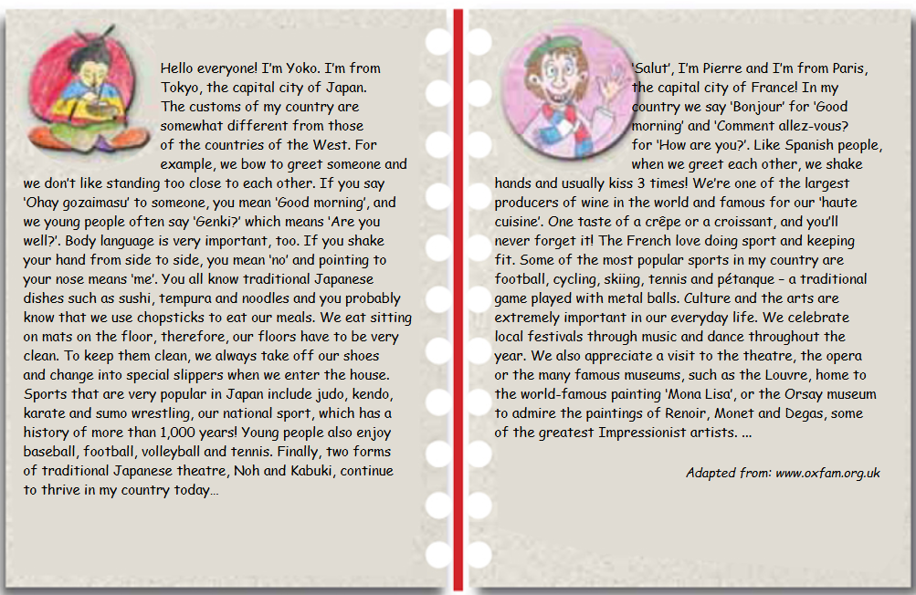
A GLIMPSE INTO MY COUNTRY

